1 run

training 1 epoch...

113.98674750328064 seconds used......

1 training finished! average train loss: 1.0079557789783729

evaluating...

Confusion matrix, without normalization

[[ 97 21 3]

[ 36 68 3]

[197 102 59]]

Normalized confusion matrix

[[0.80165289 0.17355372 0.02479339]

[0.3364486 0.63551402 0.02803738]

[0.55027933 0.2849162 0.16480447]]

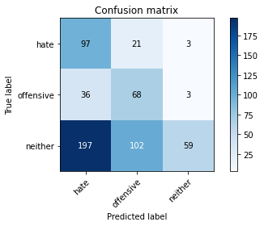

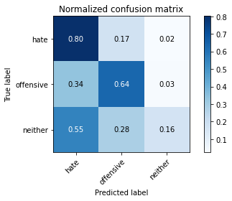

precision recall f1-score support

hate 0.29 0.80 0.43 121

offensive 0.36 0.64 0.46 107

neither 0.91 0.16 0.28 358

accuracy 0.38 586

macro avg 0.52 0.53 0.39 586

weighted avg 0.68 0.38 0.34 586

average eval_loss: 1.0484030326207479, accuracy: 0.3822525597269625

training 2 epoch...

120.13630318641663 seconds used......

2 training finished! average train loss: 0.865538455938038

evaluating...

Confusion matrix, without normalization

[[ 49 23 49]

[ 20 65 22]

[ 82 80 196]]

Normalized confusion matrix

[[0.40495868 0.19008264 0.40495868]

[0.18691589 0.60747664 0.20560748]

[0.22905028 0.22346369 0.54748603]]

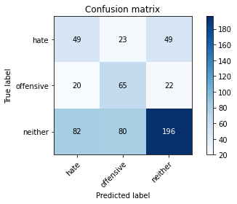

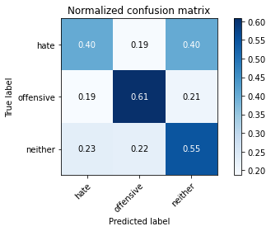

precision recall f1-score support

hate 0.32 0.40 0.36 121

offensive 0.39 0.61 0.47 107

neither 0.73 0.55 0.63 358

accuracy 0.53 586

macro avg 0.48 0.52 0.49 586

weighted avg 0.59 0.53 0.54 586

average eval_loss: 0.8949219326178233, accuracy: 0.5290102389078498

training 3 epoch...

120.36866426467896 seconds used......

3 training finished! average train loss: 0.715297743678093

evaluating...

Confusion matrix, without normalization

[[ 60 27 34]

[ 21 67 19]

[100 90 168]]

Normalized confusion matrix

[[0.49586777 0.2231405 0.28099174]

[0.19626168 0.62616822 0.17757009]

[0.27932961 0.25139665 0.46927374]]

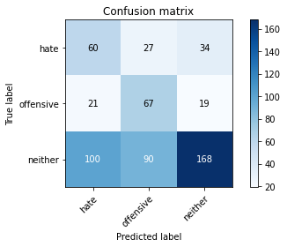

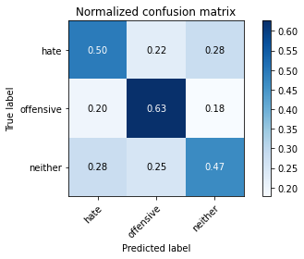

precision recall f1-score support

hate 0.33 0.50 0.40 121

offensive 0.36 0.63 0.46 107

neither 0.76 0.47 0.58 358

accuracy 0.50 586

macro avg 0.49 0.53 0.48 586

weighted avg 0.60 0.50 0.52 586

average eval_loss: 0.9740934848785401, accuracy: 0.5034129692832765

training 4 epoch...

120.16830658912659 seconds used......

4 training finished! average train loss: 0.4944153454546866

evaluating...

Confusion matrix, without normalization

[[ 55 35 31]

[ 16 72 19]

[105 94 159]]

Normalized confusion matrix

[[0.45454545 0.2892562 0.25619835]

[0.14953271 0.6728972 0.17757009]

[0.29329609 0.26256983 0.44413408]]

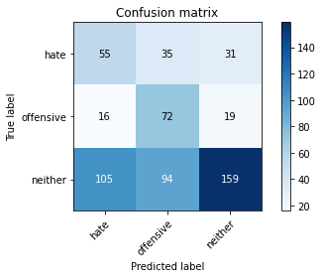

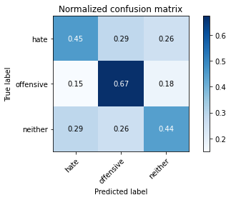

precision recall f1-score support

hate 0.31 0.45 0.37 121

offensive 0.36 0.67 0.47 107

neither 0.76 0.44 0.56 358

accuracy 0.49 586

macro avg 0.48 0.52 0.47 586

weighted avg 0.59 0.49 0.50 586

average eval_loss: 1.3211849292119344, accuracy: 0.4880546075085324

training 5 epoch...

120.27992963790894 seconds used......

5 training finished! average train loss: 0.22098851475962683

evaluating...

Confusion matrix, without normalization

[[ 75 22 24]

[ 29 64 14]

[145 83 130]]

Normalized confusion matrix

[[0.61983471 0.18181818 0.19834711]

[0.27102804 0.59813084 0.13084112]

[0.40502793 0.23184358 0.36312849]]

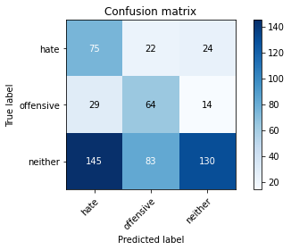

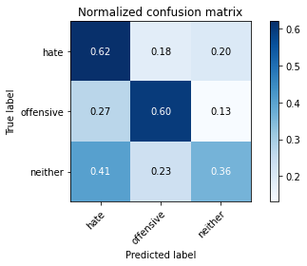

precision recall f1-score support

hate 0.30 0.62 0.41 121

offensive 0.38 0.60 0.46 107

neither 0.77 0.36 0.49 358

accuracy 0.46 586

macro avg 0.48 0.53 0.45 586

weighted avg 0.60 0.46 0.47 586

average eval_loss: 1.9271100640296936, accuracy: 0.4590443686006826

model of 1 epoch

Confusion matrix, without normalization

[[104 19 1]

[ 61 101 2]

[765 69 31]]

Normalized confusion matrix

[[0.83870968 0.15322581 0.00806452]

[0.37195122 0.61585366 0.01219512]

[0.88439306 0.07976879 0.03583815]]

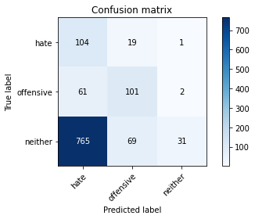

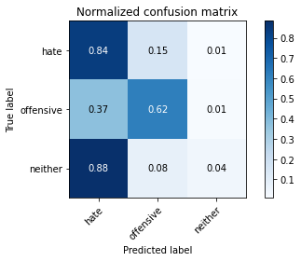

precision recall f1-score support

hate 0.11 0.84 0.20 124

offensive 0.53 0.62 0.57 164

neither 0.91 0.04 0.07 865

accuracy 0.20 1153

macro avg 0.52 0.50 0.28 1153

weighted avg 0.77 0.20 0.15 1153

average eval_loss: 1.0804327376957596, accuracy: 0.204683434518647

2 run

training 1 epoch...

66.15886688232422 seconds used......

1 training finished! average train loss: 0.99876739986633

evaluating...

Confusion matrix, without normalization

[[ 20 38 63]

[ 7 76 24]

[ 27 97 234]]

Normalized confusion matrix

[[0.16528926 0.31404959 0.52066116]

[0.06542056 0.71028037 0.22429907]

[0.07541899 0.27094972 0.65363128]]

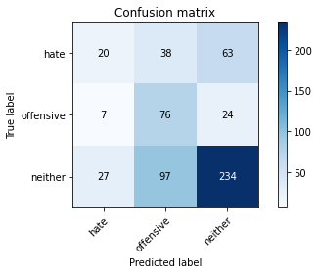

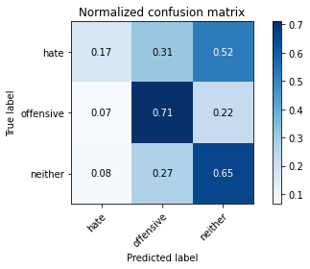

precision recall f1-score support

hate 0.37 0.17 0.23 121

offensive 0.36 0.71 0.48 107

neither 0.73 0.65 0.69 358

accuracy 0.56 586

macro avg 0.49 0.51 0.47 586

weighted avg 0.59 0.56 0.56 586

average eval_loss: 0.896388570467631, accuracy: 0.5631399317406144

training 2 epoch...

65.18614435195923 seconds used......

2 training finished! average train loss: 0.8648607581853867

evaluating...

Confusion matrix, without normalization

[[ 79 24 18]

[ 27 69 11]

[138 90 130]]

Normalized confusion matrix

[[0.65289256 0.19834711 0.14876033]

[0.25233645 0.64485981 0.10280374]

[0.38547486 0.25139665 0.36312849]]

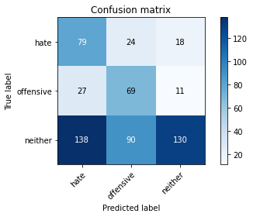

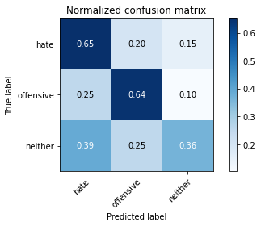

precision recall f1-score support

hate 0.32 0.65 0.43 121

offensive 0.38 0.64 0.48 107

neither 0.82 0.36 0.50 358

accuracy 0.47 586

macro avg 0.51 0.55 0.47 586

weighted avg 0.64 0.47 0.48 586

average eval_loss: 0.97628373503685, accuracy: 0.47440273037542663

training 3 epoch...

65.14246273040771 seconds used......

3 training finished! average train loss: 0.7070539879955744

evaluating...

Confusion matrix, without normalization

[[ 62 31 28]

[ 17 74 16]

[ 98 93 167]]

Normalized confusion matrix

[[0.51239669 0.25619835 0.23140496]

[0.1588785 0.69158879 0.14953271]

[0.27374302 0.25977654 0.46648045]]

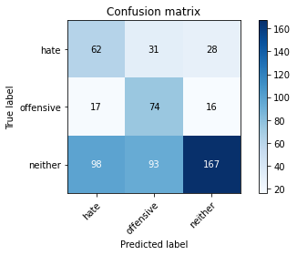

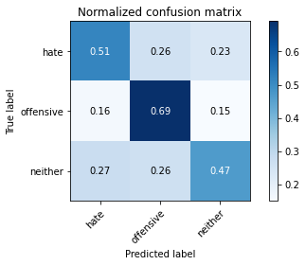

precision recall f1-score support

hate 0.35 0.51 0.42 121

offensive 0.37 0.69 0.49 107

neither 0.79 0.47 0.59 358

accuracy 0.52 586

macro avg 0.51 0.56 0.50 586

weighted avg 0.62 0.52 0.53 586

average eval_loss: 1.0429391821225484, accuracy: 0.5170648464163823

training 4 epoch...

65.1755735874176 seconds used......

4 training finished! average train loss: 0.44353808766525044

evaluating...

Confusion matrix, without normalization

[[ 93 12 16]

[ 41 47 19]

[189 47 122]]

Normalized confusion matrix

[[0.76859504 0.09917355 0.1322314 ]

[0.38317757 0.43925234 0.17757009]

[0.52793296 0.13128492 0.34078212]]

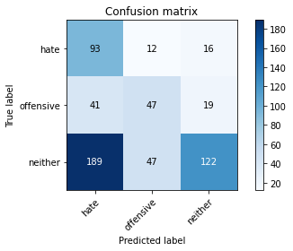

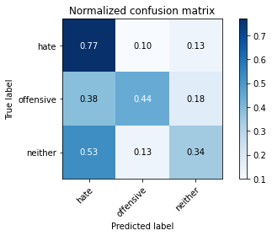

precision recall f1-score support

hate 0.29 0.77 0.42 121

offensive 0.44 0.44 0.44 107

neither 0.78 0.34 0.47 358

accuracy 0.45 586

macro avg 0.50 0.52 0.44 586

weighted avg 0.62 0.45 0.46 586

average eval_loss: 1.4747246742248534, accuracy: 0.447098976109215

training 5 epoch...

65.16719889640808 seconds used......

5 training finished! average train loss: 0.20403498131781816

evaluating...

Confusion matrix, without normalization

[[ 83 17 21]

[ 34 55 18]

[166 60 132]]

Normalized confusion matrix

[[0.68595041 0.14049587 0.17355372]

[0.31775701 0.51401869 0.1682243 ]

[0.46368715 0.16759777 0.36871508]]

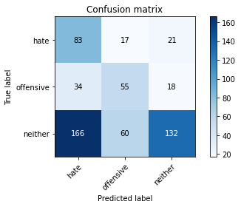

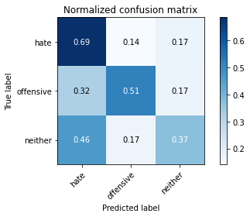

precision recall f1-score support

hate 0.29 0.69 0.41 121

offensive 0.42 0.51 0.46 107

neither 0.77 0.37 0.50 358

accuracy 0.46 586

macro avg 0.49 0.52 0.46 586

weighted avg 0.61 0.46 0.47 586

average eval_loss: 2.002221139272054, accuracy: 0.46075085324232085

Confusion matrix, without normalization

[[106 12 6]

[ 61 96 7]

[610 42 213]]

Normalized confusion matrix

[[0.85483871 0.09677419 0.0483871 ]

[0.37195122 0.58536585 0.04268293]

[0.70520231 0.04855491 0.24624277]]

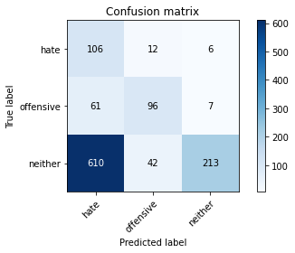

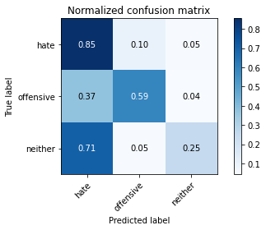

precision recall f1-score support

hate 0.14 0.85 0.24 124

offensive 0.64 0.59 0.61 164

neither 0.94 0.25 0.39 865

accuracy 0.36 1153

macro avg 0.57 0.56 0.41 1153

weighted avg 0.81 0.36 0.41 1153

average eval_loss: 1.6911473253677631, accuracy: 0.3599306157849089

[19]:

0.3599306157849089

3 run

training 1 epoch...

65.16971206665039 seconds used......

1 training finished! average train loss: 1.0142647545588643

evaluating...

Confusion matrix, without normalization

[[ 82 23 16]

[ 22 74 11]

[167 100 91]]

Normalized confusion matrix

[[0.67768595 0.19008264 0.1322314 ]

[0.20560748 0.69158879 0.10280374]

[0.46648045 0.27932961 0.25418994]]

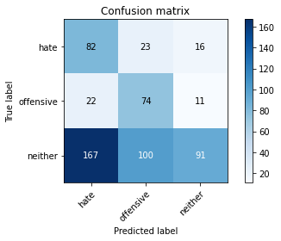

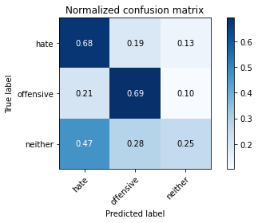

precision recall f1-score support

hate 0.30 0.68 0.42 121

offensive 0.38 0.69 0.49 107

neither 0.77 0.25 0.38 358

accuracy 0.42 586

macro avg 0.48 0.54 0.43 586

weighted avg 0.60 0.42 0.41 586

average eval_loss: 0.9660111665725708, accuracy: 0.42150170648464164

training 2 epoch...

65.14713978767395 seconds used......

2 training finished! average train loss: 0.8633771872049884

evaluating...

Confusion matrix, without normalization

[[ 85 19 17]

[ 32 63 12]

[168 67 123]]

Normalized confusion matrix

[[0.70247934 0.15702479 0.14049587]

[0.29906542 0.58878505 0.11214953]

[0.46927374 0.18715084 0.34357542]]

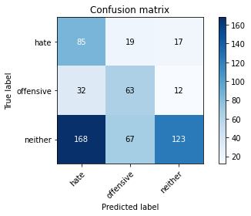

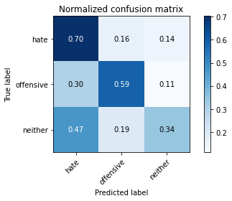

precision recall f1-score support

hate 0.30 0.70 0.42 121

offensive 0.42 0.59 0.49 107

neither 0.81 0.34 0.48 358

accuracy 0.46 586

macro avg 0.51 0.54 0.46 586

weighted avg 0.63 0.46 0.47 586

average eval_loss: 0.951601501305898, accuracy: 0.46245733788395904

training 3 epoch...

65.19686722755432 seconds used......

3 training finished! average train loss: 0.6967073382907792

evaluating...

Confusion matrix, without normalization

[[ 53 18 50]

[ 23 51 33]

[ 75 50 233]]

Normalized confusion matrix

[[0.43801653 0.14876033 0.41322314]

[0.21495327 0.47663551 0.30841121]

[0.20949721 0.1396648 0.65083799]]

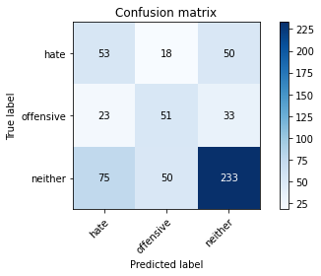

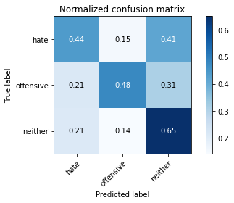

precision recall f1-score support

hate 0.35 0.44 0.39 121

offensive 0.43 0.48 0.45 107

neither 0.74 0.65 0.69 358

accuracy 0.58 586

macro avg 0.51 0.52 0.51 586

weighted avg 0.60 0.58 0.59 586

average eval_loss: 0.8963000118732453, accuracy: 0.5750853242320819

training 4 epoch...

65.13319754600525 seconds used......

4 training finished! average train loss: 0.43298422893215166

evaluating...

Confusion matrix, without normalization

[[ 67 17 37]

[ 28 61 18]

[133 66 159]]

Normalized confusion matrix

[[0.55371901 0.14049587 0.30578512]

[0.26168224 0.57009346 0.1682243 ]

[0.37150838 0.18435754 0.44413408]]

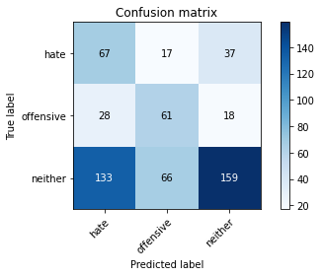

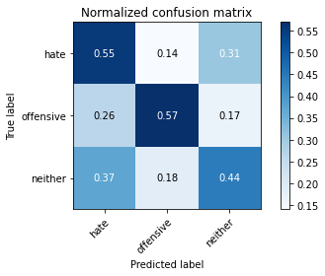

precision recall f1-score support

hate 0.29 0.55 0.38 121

offensive 0.42 0.57 0.49 107

neither 0.74 0.44 0.56 358

accuracy 0.49 586

macro avg 0.49 0.52 0.48 586

weighted avg 0.59 0.49 0.51 586

average eval_loss: 1.3356476624806721, accuracy: 0.48976109215017066

training 5 epoch...

65.1666669845581 seconds used......

5 training finished! average train loss: 0.20102718798443675

evaluating...

Confusion matrix, without normalization

[[ 40 30 51]

[ 15 69 23]

[ 86 85 187]]

Normalized confusion matrix

[[0.33057851 0.24793388 0.4214876 ]

[0.14018692 0.64485981 0.21495327]

[0.24022346 0.23743017 0.52234637]]

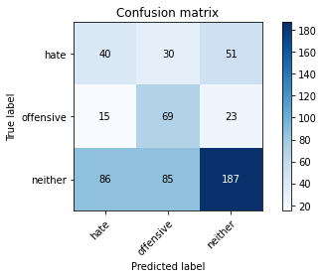

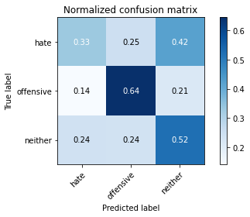

precision recall f1-score support

hate 0.28 0.33 0.31 121

offensive 0.38 0.64 0.47 107

neither 0.72 0.52 0.60 358

accuracy 0.51 586

macro avg 0.46 0.50 0.46 586

weighted avg 0.56 0.51 0.52 586

average eval_loss: 1.7314266383647918, accuracy: 0.5051194539249146

Confusion matrix, without normalization

[[ 97 22 5]

[ 47 112 5]

[590 63 212]]

Normalized confusion matrix

[[0.78225806 0.17741935 0.04032258]

[0.28658537 0.68292683 0.0304878 ]

[0.68208092 0.07283237 0.24508671]]

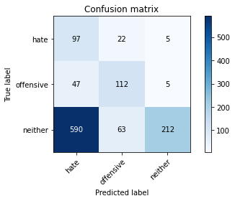

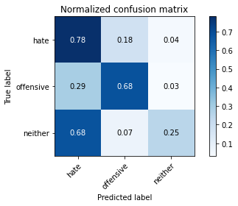

precision recall f1-score support

hate 0.13 0.78 0.23 124

offensive 0.57 0.68 0.62 164

neither 0.95 0.25 0.39 865

accuracy 0.37 1153

macro avg 0.55 0.57 0.41 1153

weighted avg 0.81 0.37 0.41 1153

average eval_loss: 0.9601125922696344, accuracy: 0.36513443191673894

[21]:

0.36513443191673894